# **Лабораторна робота №1**

**Тема:** “Знайомство з робочим середовищем віртуальних машин та особливостями операційної системи Linux”

**Мета роботи:**

1. Знайомство з гіпервізорами різного типу, віртуалізацією при роботі з операційними системами.

2. Знайомство з основними видами сучасних ОС, короткий огляд їх можливостей.

**Матеріальне забезпечення занять:**

1. ЕОМ типу IBM PC.

2. ОС сімейства Windows та віртуальна машина Virtual Box (Oracle).

3. ОС GNU/Linux (будь-який дистрибутив).

4. Сайт мережевої академії Cisco netacad.com та його онлайн курси по Linux

## Створив Трощинський Ярослав

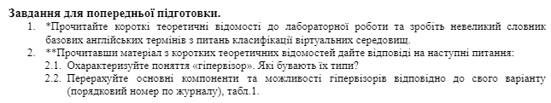1. Read the short theoretical information for the laboratory work and make a small dictionary of basic English terms on the classification of virtual environments.

2. After reading the material from short theoretical information, answer the following questions:

1. Describe the concept of "hypervisor". What are their types?
2. List the main components and capabilities of hypervisors according to your option (serial number by journal), Table 1.

1.Some of the new English terms I`ve found:

* Kernel - the central controller of everything that happens on the computer. Синонім слова ядро(core)
* GNU is the free software that provides open source equivalents of many common UNIX commands
* UNIX, an operating system developed at AT&T Bell Labs in the 1970s
* The open source is when you have a right to obtain the software source code and to modify it for your own use
* Distribution is often referred to the kernel, tools and suite of applications that come bundled together
* Graphical user interface is when applications present themselves in windows that can be resized and moved around
* Command line interface is a text-based interface to the computer, it relies primarily on keyboard input

2.1. Hypervisor is a software that can be used to run multiple virtual machines on a single physical machine. There are 2 types of hypervisors, the main difference between them is effectiveness. While 1 type makes all decisions directly, 2 type make use of the host operating system and its file system to create processes, store files, and so on.

2.5. Answers to p. 2.1 and p. 2.2 from tasks for preliminary training

2.5.1 List the steps for deploying an operating system based on a VirtualBox virtual machine.

For personal usage of VirtualBox you need to follow this guide:

1. Download application from internet
2. Install and open it
3. Click “Create” in the tool window and enter a name
4. Select the type, version and amount of RAM that will be allocated to virtual machine
5. Specify the hard disk parameters
6. Click “Create” and “Continue”
7. The next and final step, install selected version of OS you chose of subparagraph 4

2.5.2 Are there any hardware limitations when installing 32-bit and 64-bit OS?

Yes, if you try to run a 64-bit OS on a 32-bit PC, it won't even boot up. And when you boot a 32-bit OS on a 64-bit PC, usable RAM will be limited to an amount of 4 GB.

## Створив Когут Богдан

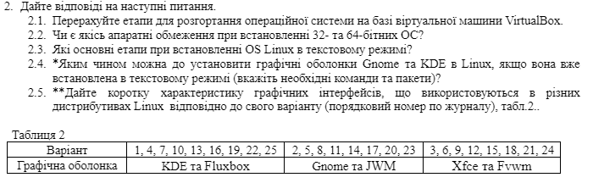

2. Answer the following questions:

2.1. List the steps for deploying an operating system based on a VirtualBox virtual machine.

2.2. Are there any hardware limitations when installing 32-bit and 64-bit operating systems?

2.3. What are the main steps for installing a Linux OS in text mode?

2.4. How can you install the Gnome and KDE graphical shells in Linux if it has already been installed in text mode (specify the necessary commands and packages)?

2.5. Provide a brief description of the graphical interfaces used in different Linux distributions according to your variant (refer to Table 2).

**2.1. Steps for deploying an OS based on VirtualBox:**

1. Install VirtualBox: Download and install VirtualBox on your host machine.

2. Create a New Virtual Machine (VM): Open VirtualBox and click "New" to create a new virtual machine. Set the name, type of OS, and version (32-bit or 64-bit).

3. Allocate Memory (RAM): Choose the amount of RAM for the virtual machine, typically between 1 to 2 GB for lightweight Linux distributions.

4. Create Virtual Hard Disk: Select the option to create a new virtual hard disk and choose the size (e.g., 20 GB or more depending on the OS).

5. Select the Installation ISO: Under the "Storage" section, choose the ISO file for the OS installation.

6. Start the VM: Start the VM, and the OS installation will begin from the selected ISO.

**2.2. Hardware limitations when installing 32-bit and 64-bit OS:**

- 32-bit OS: Can only use up to 4 GB of RAM. It is recommended for older hardware or processors that don't support 64-bit.

- 64-bit OS: Requires a 64-bit processor and allows for more than 4 GB of RAM. Modern hardware generally supports 64-bit, making it the standard choice for most installations.

**2.3. Main steps for installing Linux OS in text mode:**

Start from installation media: Boot from a CD or USB where your Linux installer is stored.

Choose text mode installation: Select the text-based installation option.

Set up disk partitions: Use tools like fdisk to create partitions on your hard drive.

Install the basic system: Download and install the core packages needed to run Linux.

Install a bootloader: Add a program like GRUB so your system can boot properly.

Set up network: Configure network settings either by editing files or using simple text-based tools.

Reboot: After installation, restart your system and log in.

**2.4. How to install Gnome and KDE if Linux is in text mode:**

**For Gnome:**

1. Update your package manager:

sudo apt update

2. Install Gnome:

sudo apt install gnome-shell

3. Start Gnome with this command:

sudo systemctl start gdm3

4. Set Gnome to start automatically:

sudo systemctl enable gdm3

**For KDE:**

1. Install KDE:

sudo apt install kde-plasma-desktop

2. Start KDE’s display manager:

sudo systemctl start sddm

3. Set KDE to start automatically:

sudo systemctl enable sddm

**2.5. Brief description of graphical interfaces (for KDE and Fluxbox):**

**- KDE:**

- KDE is a powerful and feature-rich desktop environment. It’s highly customizable and offers a lot of advanced settings, making it great for users who want more control over their system’s appearance and behavior. KDE comes with a full suite of applications like file managers, text editors, and system settings tools. It is known for being visually appealing while still performing well on modern systems.

**- Fluxbox:**

- Fluxbox is a lightweight window manager that focuses on speed and simplicity. Unlike KDE, it doesn’t come with a lot of built-in apps or features. Instead, it provides a minimalistic environment where users can open windows and manage tasks efficiently. It’s great for older hardware or when you want a clean, fast interface without extra features.

## Створив Михайленко Олексій